

Download Oracle Database 11g Express Edition

Click on the setup file

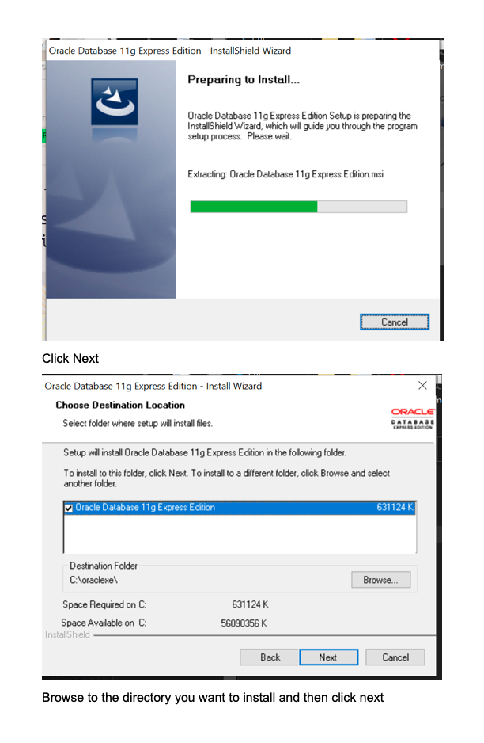

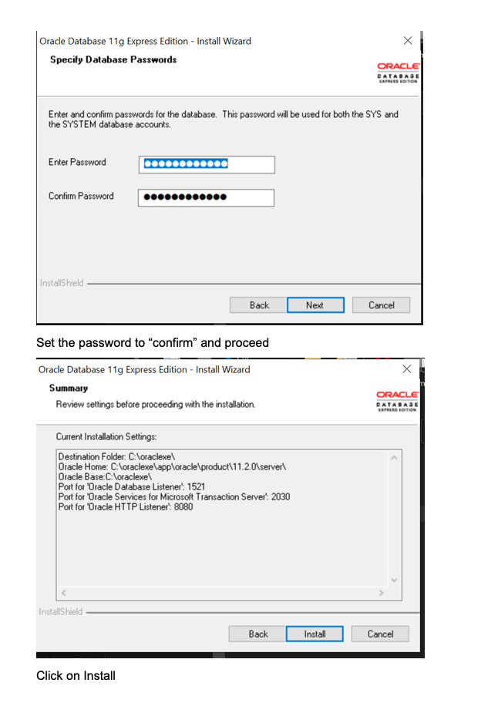

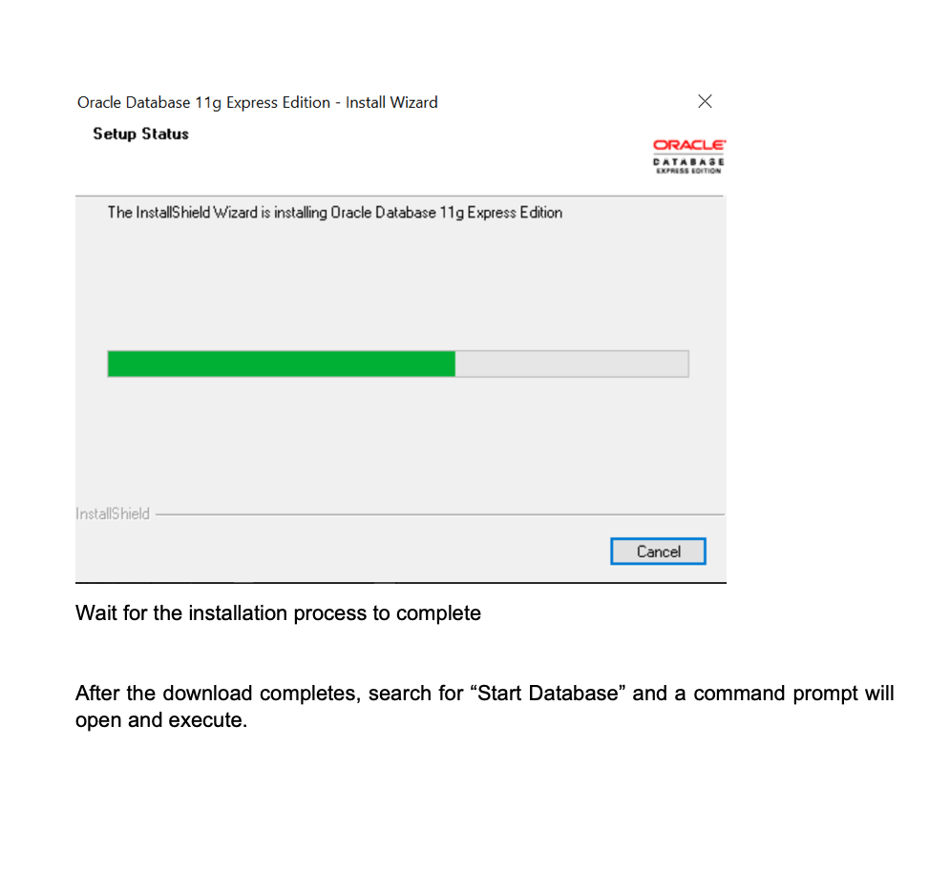

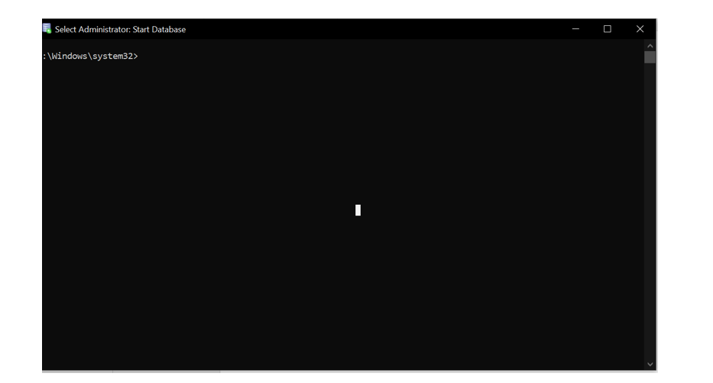

Close the Command prompt once this shows up

Open which browser you like and go to the following link

[**http://127.0.0.1:8080/apex/f?p=4950:1:1204799924348321:::::**](http://127.0.0.1:8080/apex/f?p=4950:1:1204799924348321:::::)

Enter username and Password

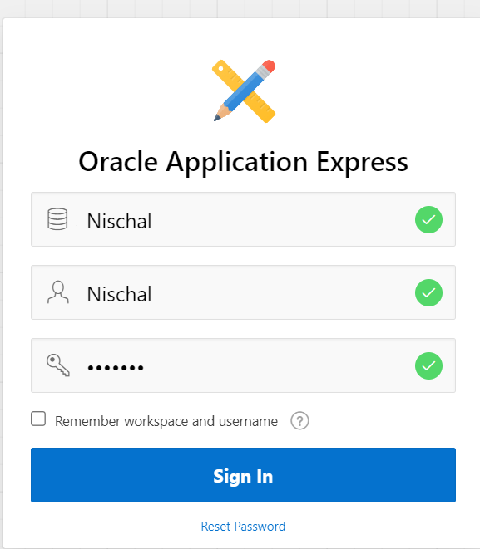

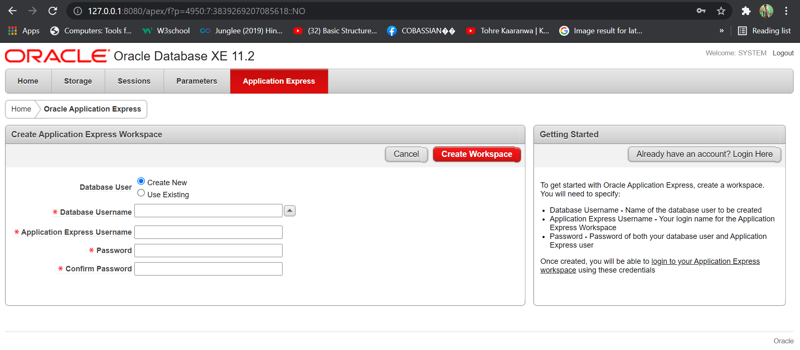

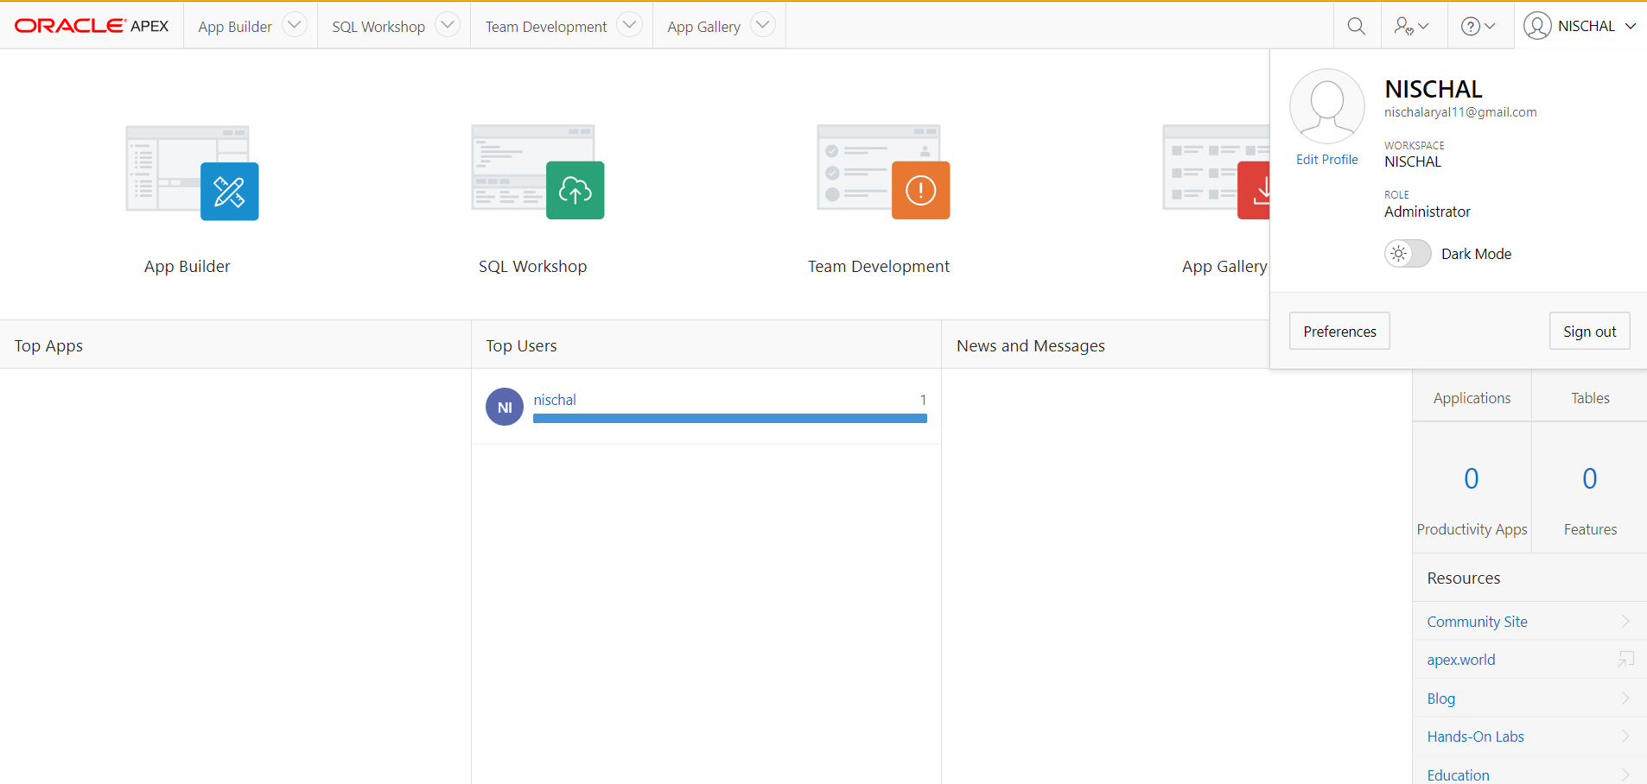

This is the home page of oracle apex.

Click on upload to upload the script

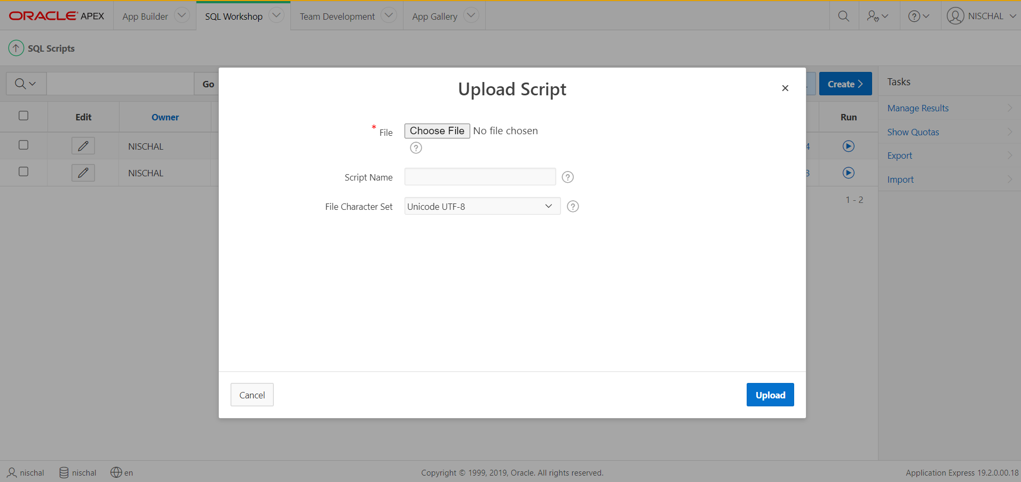

Click “Choose File” and upload the sql file.

Additional Setup

On the Apache section, click on Config and select PHP (php.ini) from the dropdown menu.

